# Chapter 7 Climate Action

**Green Action Milestones**

|  |  |
| --- | --- |
| **Year** | **Highlight Achievements** |
| 2016 | * Obtained the ISO 14001 Environmental Management System Certification. * Obtained the ISO 14064-1 Organization Greenhouse Gas Inventory System Certification. * Requested suppliers to include the “Commitment Statement for Human Rights and Environmental Sustainability Terms” in procurement contracts. * Participated in the “Ministry of Economic Affairs’ voluntary green tariff system pilot program”. |
| 2017 | * Revised procurement regulations to give priority to green products. |
| 2018 | * Obtained the ISO 50001 Energy Management System Certification. * Purchased renewable energy certificates. * Awarded the "Healthy Workplace Certification”. |
| 2019 | * Convened the first supplier conference. * Installed iEN Intelligent Energy Saving System in self-owned buildings to refine ISO 50001 Energy Management System. |
| 2020 | * Signed the power purchase agreement (PPA), being the first securities company in Taiwan to do so.   • Introduced ISO 20400 Sustainable Procurement Guidance.   * Introduced ISO 14046 Water Footprint Inventory. * Requested suppliers to sign the “Supplier’s Terms and Conditions for Sustainable Procurement” and “Supplier Sustainable Procurement Guidelines”. |
| 2021 | * Became the first in Taiwan’s financial industry with its branches transitioned to 100% green power. * Being the first financial institutions in Taiwan to introduce ISO/PAS 45005 General Guidelines for Safe Working during the COVID-19 pandemic. * Introduced Internal Carbon Pricing (ICP) Mechanism following Yuanta Financial Holdings. |
| 2022 | * Launched the first zero-carbon app in the securities industry: Mr. Yuanta APP obtained the ISO 14067 Carbon footprint of products and PAS 2060 Carbon Neutrality Certifications. |
| 2023 | * The Board of Directors approved the enactment of “Yuanta Securities Co., Ltd. and Subsidiaries Environment, Energy and Climate Change Management Policy”. * “Yuanta Securities Online Financial Service” passed the ISO 14067 Carbon footprint of products Certification and obtained the Carbon Footprint Label of the Ministry of Environment. * Purchased carbon credits from wind power projects in India via the Taiwan Carbon Exchange, being one of the first enterprises to make a purchase in the international carbon trading platform. |

## 7.1 Climate Change Management

**Climate Governance and Responsibility Allocation**

**Climate Change Management Policy**

To achieve sustainable development and address international energy shortages and climate change, Yuanta Securities has been engaging in the work of the parent company Yuanta Financial Holdings’ Task Force on Climate-Related Financial Disclosures (TCFD) since 2020. In accordance with the Financial Supervisory Commission’s “Transition Strategies of Sustainable Development for Securities and Futures Sectors”, environmental sustainability considerations are incorporated into our management and operations as we promote climate change-related initiatives. We have also established the “Yuanta Securities Co., Ltd. and Subsidiaries Environment, Energy, and Climate Change Management Policy”, committed to promoting environmental and energy management, practicing effective energy utilization, reducing greenhouse gas emissions, and implementing environmental protection. In addition, the “Yuanta Securities Co., Ltd. Management Measures for Climate Change Risk in Investment” is in place, which outlines the Company’s standards for climate change risk management in investment to ensure the appropriateness of relevant operations.

**Board of Directors’ Involvement and Promotion**

The impact of climate change is increasingly significant for corporate operations. Therefore, professional knowledge in sustainable management is prioritized in the considerations for the composition of Yuanta Securities’ Board of Directors. In addition to the professional capabilities in financial institution management and operations, financial management, accounting, law, and corporate governance when nominating independent directors, we also emphasize practical experience, knowledge, and skills in climate change-related issues.

The Company abides by the “Risk Management Policy”, with the Board of Directors being the highest decision-making body for risk management. To enhance climate-related risk management, relevant management systems, regulations, and climate risk monitoring indicators for supervision are also in place. The Risk Management Department reports on the implementation of climate-related risk management to the Sustainable Development Reporting Committee, the Audit Committee, and the Board of Directors.

**Responsibilities of Senior Management**

The President (or designated supervisory officer) is responsible for regularly convening the Sustainable Development Reporting Committee to oversee the Company’s climate change-related development, effectively manage the planning and response to climate change-related strategies, and track the implementation of annual indicators and targets. This ensures effective management and control of climate change-related risks in the Company’s operations and further mitigates the impact of climate change risks on the Company through the promotion of ESG-related products and services or energy-saving and carbon reduction actions.

**Linking Senior Management Performance to ESG**

To achieve sustainability goals and enhance organizational operational efficiency, the Company revised the “Performance Management Measures” in 2020, incorporating ESG-related goals into performance assessment indicators. ESG sustainability promotion items, including climate management, have been added to the performance indicators for senior managers to ensure that all levels of management strive for profitability while also achieving sustainability goals. For more detailed information, please refer to Chapter 3, Section 1, “ESG Performance and Reward System”.

**Responsibilities of Functional Teams**

To continuously promote climate change-related initiatives, Yuanta Securities established the “Climate Change Risk Management Team” under the Sustainable Development Reporting Committee in July 2023. This team is responsible for establishing climate-related management systems and regulations, disclosing climate-related information, and deliberating on financial carbon emissions and other related matters. It works closely with the Environmental Sustainability Team and the Sustainable Finance Team to jointly develop strategies for addressing climate-related risks and opportunities. At each quarterly work meeting, the Climate Change Risk Management Team reports on work progress and implementation effectiveness, and regularly provides the Board of Directors with updates on relevant situations and material issues.

|  |  |
| --- | --- |
| Team | Responsibilities |
| Climate Change Risk Management Team | *Establish climate-related management systems and regulations  *Disclose climate-related information  *Deliberate on greenhouse gas emissions - Scope 3 (financial carbon emissions) |
| Environmental Sustainability Team | *Formulate environmental policies and management systems  *Disclose Scope 1 and Scope 2 greenhouse gas emissions  *Purchase low-energy consumption, green-energy powered office supplies and equipment  *Properly handle waste  *Recycle and reuse energy-intensive appliances  *Manage suppliers  *Conduct green procurement projects |
| Sustainable Finance Team | *Implement matters related to sustainable finance principles and investment management policies  *Promote green operation, develop green products and green financing  *Promote responsible investment and institutional investor stewardship  *Respond to climate change and development  *Promote products and services that provide environmental and social benefits  *Promote financial inclusion |

**Climate Change-Related Risk Management**

**Climate Risk Management Policy**

Yuanta Securities has a comprehensive risk management organizational structure, policies, and management regulations in place, covering financial risk, operational risk, legal and compliance risk, and climate change risk. These policies also consider multiple aspects such as environmental protection (E), social responsibility (S), and corporate governance (G). Climate change risk has been incorporated into our risk management policy, with specific mechanisms established for climate risk management. These mechanisms clearly define the responsibilities of relevant units and various risk management procedures, monitoring items, and threshold values for monitoring indicators. With the climate change risk management process integrated into our overall risk management procedures, the Company’s ability to manage climate risks is enhanced. Moreover, our “Management Measures for Climate Change Risk in Investment” and “Operational Risk Management Measures” outline standards for managing climate change risks in investments and operations, ensuring the appropriateness of risk management. Through identification, measurement, monitoring, and reporting, we ensure that the climate change risks faced in the Company’s various businesses meet risk management objectives and risk tolerance levels.

**Climate Risk Management Procedure**

|  |  |  |  |
| --- | --- | --- | --- |
| **Risk and opportunity identification** | **Risk and opportunity measurement** | **Risk and opportunity monitoring** | **Risk and opportunity report** |
| 1. In line with Yuanta Financial Holdings’ schedule, Yuanta Securities annually identifies climate risks and opportunities based on business characteristics. 2. We collaborate with Yuanta Financial Holdings’ Risk Management Department, Administration Department, and Corporate Planning Department to integrate the Company’s overall risk identification. 3. We reference international organizations’ climate risk management reports. | 1. We assess the impact and influence of various risks and opportunities based on business characteristics. 2. The measurement scope includes impact pathways, impact time and geographical scope, affected value chain positions, and financial impact. | 1. Environmental and social factors of various industries are included in the industry risk and opportunity level assessment mechanism. 2. Climate risk monitoring indicators and threshold values for the Company’s investments and operations are established and regularly monitored to control the potential impacts of climate risks. 3. We have formulated the “Investment Management Policy” and incorporated ESG and responsible investment checks and evaluations into proprietary business and investment banking underwriting business-related regulations. | 1. The implementation status of climate-related risk monitoring indicators is regularly reported to the Audit Committee and the Board of Directors. 2. Climate risk-related information is periodically reported to independent directors. 3. ESG investment implementation status is regularly reported to the Board of Directors. |

**Climate Change-Related Strategy**

**Potential Climate-Related Risks and Opportunities**

In response to the impact of climate change on the Company’s operations and the impact of our business activities on the climate, Yuanta Securities, in coordination with the schedule of our parent company, Yuanta Financial Holdings, and in collaboration with Yuanta Financial Holdings’ Risk Management Department, Administration Department, and Corporate Planning Department, annually identifies and assesses climate risks and opportunities based on the Company’s operations and business characteristics to enhance corporate resilience.

The Climate-Related Financial Disclosures (TCFD) guidelines categorize climate risks into “transition risks” pertaining to a low-carbon economy and “physical risks” associated with climate change impacts. The guidelines also list climate-related “opportunities” that can be developed under transition strategies. According to the guidelines’ classification and referencing international organizations’ climate risk reports, the Company identifies potential climate-related risks and opportunities through different impact pathways, impact time and geographical scope, value chain position affected, and financial impact. During the measurement process, we link identified potential climate risks with existing traditional risks and consider their potential financial impacts on the Company. A climate risk matrix is then created based on the materiality ranking derived from “impact = magnitude” and “impact time frame”. In 2023, the Company identified a total of six risks and seven opportunities, and corresponding measures are planned based on the impact duration and magnitude.

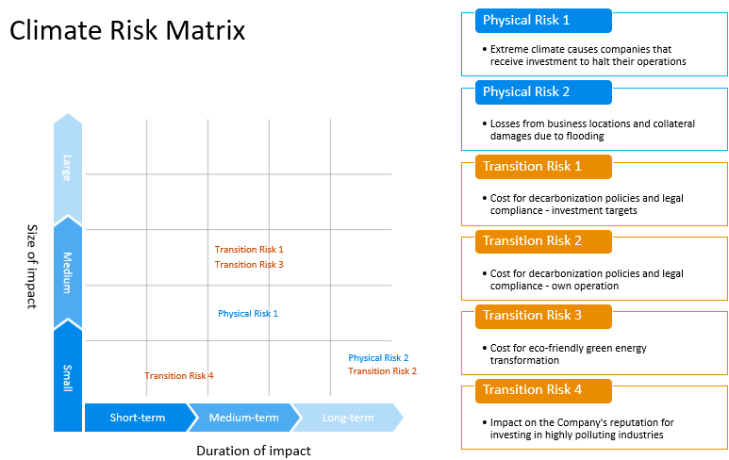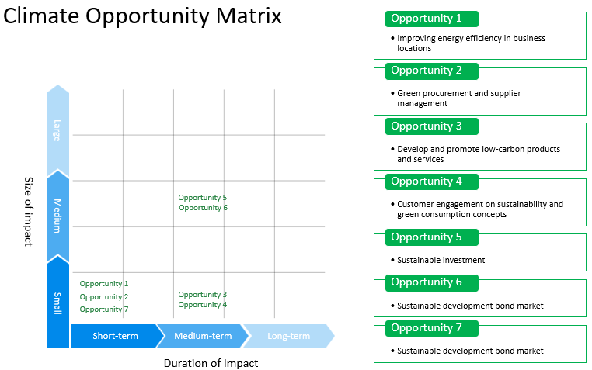

Note:

1. Time frame: Short term refers to events that may occur within one year, medium term refers to events that may occur within 1-5 years, and long term refers to events that may occur over 5 years.
2. Impact magnitude: Small (may result in profits or losses under 100 million NTD), Medium (may result in profits or reduced losses of 100-300 million NTD), Large (may result in profits or reduced losses of over 300 million NTD).

**Financial Impact of Climate Risks and Opportunities and Response Measures**

**Financial Impact Analysis of Climate Risks**

|  |  |  |  |  |  |
| --- | --- | --- | --- | --- | --- |
| **Risk aspect** | | **Impact period** | **Corresponding existing risk** | **Potential financial impact**  **on Yuanta Securities** | **Response measures** |
| Transition Risk | Impact on company reputation due to investment in high-pollution industry | Short to medium term | Credit risk | Negative news is reported on high-pollution enterprises the Company invest in, thereby affecting the Company’s reputation. | Enhance the review and control of, and engagement with high-pollution enterprises the Company invest in, and strive to be a sustainable financial institution through voluntary advocacy or joining international initiatives, building a positive social image. |
| Costs for investment targets in response to decarbonization policies and regulations | Medium term | Market risk  Credit risk  Liquidity risk | Investment targets may incur additional carbon reduction costs due to stricter regulations or lack of transition technology, leading to reduced profits and falling stock prices, resulting in decreased assets for the Company. | Continue to monitor trends in international carbon taxes and carbon-related regulations, and strengthen engagement actions for high-carbon investment targets. |
| Costs of industry green energy and environmental protection transformation | Medium term | Market risk  Credit risk  Liquidity risk | Investment targets may incur additional costs due to transformation, or experience reduced revenue due to untimely transformation, resulting in decreased assets for the Company. | Continue to monitor market demand for low-carbon transformation and assist investment targets in low-carbon transformation. |
| Operational costs for the Company in response to decarbonization policies and regulations | Long term | Strategy risk | To achieve carbon reduction targets and comply with domestic policies and regulations, using renewable energy as a carbon reduction measure may incur additional costs, leading to increased operational costs for the Company. | Continue to monitor and engage in the renewable energy market, and actively improve energy efficiency at operating sites to reduce the use of externally purchased electricity. |
| Physical Risk | Operating sites and collateral losses due to flooding | Medium term | Operational risk | Flooding caused by extreme weather may lead to operating site interruptions or a decline in the value of company-owned real estate, affecting the Company’s profits and resulting in reduced income or decreased assets. | Incorporate climate change-induced flooding factors in the consideration for operating sites and real estate investments. |
| Business disruption of investment targets due to extreme weather | Medium term | Market risk  Credit risk  Operational risk  Liquidity risk | Investment targets may suffer property losses or operational disruptions due to extreme weather, resulting in reduced assets for the Company. | Strengthen due diligence processes for investment targets to understand their resilience to extreme weather. |

**Financial Impact Analysis of Climate Opportunities**

|  |  |  |  |
| --- | --- | --- | --- |
| **Opportunity aspect** | **Impact period** | **Potential financial impact on Yuanta Securities** | **Response measures** |
| Energy efficiency enhancement at operating sites | Short term | Energy efficiency enhancements such as adopting green building practices, using renewable energy, switching to energy-efficient equipment, and implementing energy management systems can reduce operational costs. | Adopt the ISO 50001 energy management system, directly purchase renewable energy (transition to green power), actively switch to energy-saving lighting and water-saving equipment, replace air conditioning with first-class energy-saving labeled equipment, and strengthen employee advocacy for energy-saving behaviors. |
| Green procurement and supplier management | Short term | Supporting enterprises with low-carbon and sustainable products through the implementation of green procurement and supplier management can reduce operational costs. | Abide by Yuanta Financial Holdings’ “Sustainable Procurement Declaration,” “Integrity Management Guidelines,” “Procedures for Integrity Management and Guidelines for Conduct”, “Supplier Sustainable Procurement Guidelines,” and “Supplier Management Guidelines,” and include the “Integrity Commitment Statement” and “Supplier’s Terms and Conditions for Sustainable Procurement” in supplier contracts to regulate suppliers; the procurement regulations also include “Green Procurement Terms and Conditions”. |
| Development and promotion of low-carbon products and services | Medium term | The development and promotion of low-carbon products and services can meet investor needs and increase business revenue. | Launch diversified and innovative financial products with themes of climate change and sustainability, such as sustainable Exchange Traded Notes (ETNs) and sustainability-related warrants, to meet customers’ sustainable investment needs. Furthermore, leverage multiple channels to promote existing sustainable products, continuously expand the scale of sustainable asset management, and actively guide funds into ESG industries, supporting invested companies with sustainable operations as their goal. Conduct carbon footprint assessments and carbon neutrality operations for the Company’s related financial products and services, such as apps and online services, to provide customers with low-carbon financial products and services that meet their needs, thereby increasing revenue. |
| Customer engagement on sustainability and green consumption concepts | Medium term | The utilization of diverse means such as financial products and service platforms to interact and engage with customers on sustainability and green consumption concepts can increase business revenue. | Through multiple channels such as the official website and apps, encourage customers to participate in energy-saving and carbon-reducing initiatives or engage in green investments. For institutional investors, interact and engage through meetings, letters, phone communications, and participation in voting at shareholders’ meetings to encourage them to adopt proactive ESG measures, thereby reducing invested enterprises’ impact on society and the environment. |
| Sustainable investment | Medium term | Guiding capital to sustainable enterprises following Yuanta Group’s investment policies can increase business revenue. | Make investment decisions following Yuanta Financial Holdings’ “Sustainable Finance Guidelines” and “Industry-Specific Environmental and Social Risk Management Rules”. Proprietary trading units formulate relevant regulations and indicators based on respective business characteristics and incorporate ESG concepts into the investment evaluation process. For IPO and SPO cases undertaken by investment banking units, hold a pre-case assessment meeting to evaluate their ESG compliance. |
| Sustainability bond market | Medium term | The issuance and underwriting of and investment in sustainability bonds can increase business revenue. | Continue to participate in the sustainability bonds promoted by the Taipei Exchange (TPEx), including green bonds, sustainable bonds, social responsibility bonds, and sustainability-linked bonds (SLBs), to activate the sustainable development bond market and assist invested enterprises in sustainable transformation. |
| Natural disaster crisis handling and warning | Short term | The formulation of adaptation measures while ensuring their effectiveness secures stability in the provision of various services, thereby reducing business loss. | Introduce the ISO 22301 Business Continuity Management Systems to establish standard procedures. In addition to uninterruptible power supply equipment, backup servers, and off-site backup systems, also formulate off-site office plans and drills, and regularly conduct related drills to ensure personnel safety and reduce operational interruption risks in the event of natural disasters. |

**Scenario Analysis of Climate Change Financial Impact**

Following the schedule of Yuanta Financial Holdings Group, Yuanta Securities conducts climate change financial impact scenario analysis using a top-down approach for its overall investment positions and a bottom-up approach for individual company-scale scenario analysis. This involves a multi-faceted analysis based on the nature of the Company’s business, considering the potential climate-related financial impacts under different scenarios, time points, and durations. Through the analysis of various climate scenarios, we strengthen the Company’s climate resilience and appropriately adjust policies to adequately respond to the climate change risks we face.

**Top-Down Scenario Analysis of Overall Investment Positions**

Based on the evaluation of the impact of climate change on the overall economic environment, scenario analysis is conducted for medium- and long-term investment positions, and a quantitative method is developed for assessing the financial risks associated with climate change, serving as a reference for climate risk and opportunity management.

* Evaluation Method

To measure the physical and transition risks caused by climate change, the scenario analysis of the Company’s overall investment positions uses climate scenarios provided by two major international climate risk authorities: the Intergovernmental Panel on Climate Change (IPCC) and the Network for Greening the Financial System (NGFS). These scenarios depict the risks of long-term temperature rises and policy responses to climate change. Furthermore, a climate-linked economic model is established through the macroeconomic linkage factors and integrates the economic model with various risk factor models. This allows us to analyze the impact of climate shocks using a mature risk management model.

* Adopted Climate Scenarios

Three scenarios are set: “Orderly Transition”, “Disorderly Transition”, and “Hot House World”, to assess the impact on investment positions under different climate impact scenarios. Each scenario is depicted with combinations of physical risk and transition risk. The physical risk scenarios are referenced from the Shared Socioeconomic Pathway (SSP) scenarios in the “IPCC Sixth Assessment Report (AR6),” and the transition risk scenarios are adopted from the “NGFS Climate Scenarios Explorer”.

1. Orderly Transition Scenario

The orderly transition scenario is a combination of low physical risk and low transition risk, hence the selection of physical scenario SSP1-RCP2.6, which represents low greenhouse gas emissions. This scenario assumes a 1.7°C temperature increase by 2050. The transition risk scenario chosen is the Net Zero 2050 scenario with active transition efforts. It assumes rapid and smooth implementation of government carbon reduction policies, moderate carbon price increases, the fastest technological changes, and the highest use of carbon reduction technologies among the three scenarios.

1. Disorderly Transition Scenario

The disorderly transition scenario is a combination of low physical risk and high transition risk, hence the selection of physical scenario SSP1-RCP2.6, which represents low greenhouse gas emissions. This scenario assumes a 1.7°C temperature increase by 2050. The transition risk scenario chosen is the delayed transition scenario. It assumes delayed implementation of government carbon reduction policies, with no significant initial adjustments in carbon prices but a rapid increase later, initially slower technological changes that later accelerate, and the second-highest use of carbon reduction technologies among the three scenarios.

1. Hot House World Scenario

The hot house world scenario is a combination of high physical risk and low transition risk, hence the selection of physical scenario SSP5-RCP8.5, which represents high greenhouse gas emissions. This scenario assumes a 2.4°C temperature increase by 2050. The transition risk scenario chosen is the current policies scenario with no significant adjustment efforts. It assumes that government policies remain unchanged, with no significant adjustments in carbon prices, the slowest technological changes, and the lowest use of carbon reduction technologies among the three scenarios.

* Scenario Analysis Results

1. Climate Change Impact on Financial Transaction Value

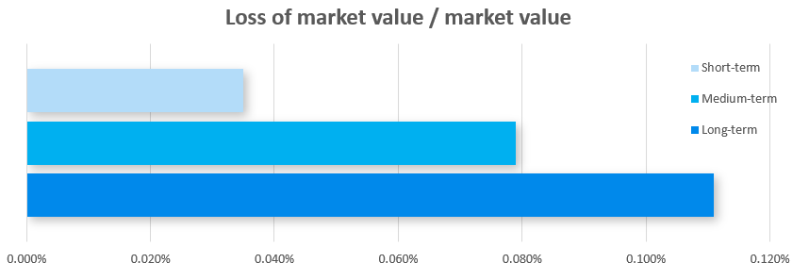The impact on the market value of financial transactions is assessed by integrating the economic damage from climate scenarios into market risk factors. The long-term relative decrease in market value for Yuanta Securities’ medium- and long-term investment positions due to climate impact is approximately 0.11% of the benchmark day’s market value, indicating that the impact of climate change is not significant.

Note:

1. The horizontal axis represents the change in market value relative to the benchmark day’s market value.
2. Short term measures the 1-year loss situation, medium term measures the 5-year loss situation, and long term measures the 10-year loss situation.
3. The bars represent the possible range of impacts under different climate scenarios within a loss period.
4. Climate Change Impact on Expected Credit Losses in Financial Transactions

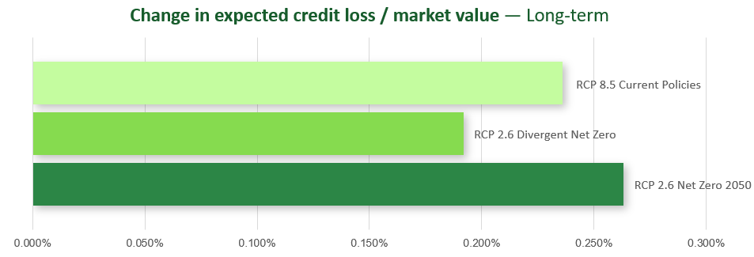The financial damage caused by the physical risks of climate change or the capital expenditure from transition risks may reduce the revenue of some financial transaction issuers and increase their credit risk. The impact on expected credit losses in financial transactions is assessed by integrating the economic damage from climate scenarios into credit risk factors. The long-term relative increase in expected credit losses for the Company’s medium- and long-term investment positions is approximately 0.26% of the benchmark day’s market value, indicating that the expected credit losses due to climate impact are not significant.

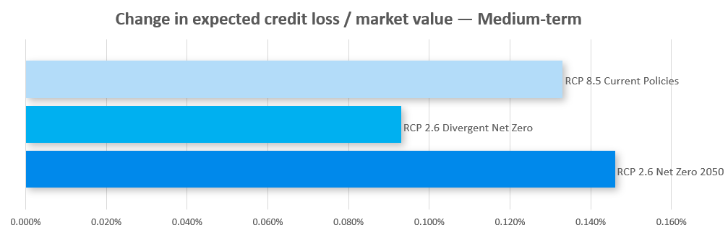Note:

1. The horizontal axis represents the expected credit loss relative to the benchmark day’s market value.
2. Medium term measures the 5-year loss situation, and long term measures the 10-year loss situation.
3. Climate Change Impact on Potential Market Liquidity Losses in Financial Transactions

Climate change may have broader impacts on the entire financial system, potentially causing sustained insufficient trading volumes or leading to market disorder, thereby significantly reducing trading volumes and resulting in additional losses when disposing of financial transactions. The potential market liquidity losses due to climate change are assessed by integrating the economic damage from climate scenarios into market liquidity risk factors. The medium- and long-term relative increase in potential market liquidity losses for the company’s medium- and long-term investment positions is approximately 0.016% of the benchmark day’s market value. Since the Company’s medium- and long-term investment positions consist primarily of senior bonds with investment-grade credit ratings, the impact of climate change on potential market liquidity losses in medium- and long-term investments is not significant.

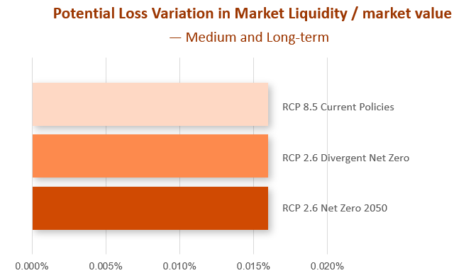

Note:

1. The horizontal axis represents the potential market liquidity losses relative to the benchmark day’s market value.
2. Medium term measures the 5-year loss situation, and long term measures the 10-year loss situation.

* Response Strategies Based on Scenario Analysis Results

The Company is consistently reducing the impact of climate risks on the value of financial products through portfolio diversification. In addition, based on the scenario analysis results, we regularly review our risk-bearing capacity and asset risks, and establish climate risk monitoring indicators according to the estimated loss values of the investment portfolio to prevent losses caused by extreme climate risks.

**High Climate Risk Industry Analysis**

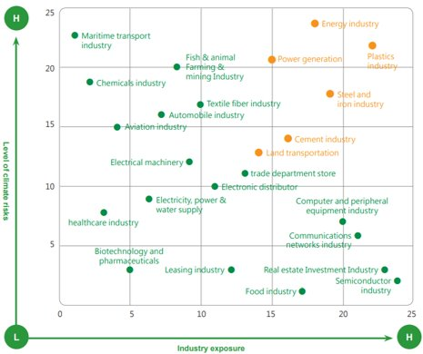Yuanta Securities conducts a comprehensive assessment of the overall financial transaction market, combining analysis report results of the Company and domestic and international industries to understand the climate risk levels of specific industries and our exposure scale. We conduct analysis of selected industries with high climate risk levels and large exposure amounts. According to the analysis results, the plastics, steel, energy, power generation, cement, and aviation industries are identified with high climate risks. With that, we further conduct bottom-up transition risk scenario analysis on the domestic and foreign equity investment positions in these high-climate-risk industries to measure the potential financial impacts of climate change.

**Bottom-up Transition Risk Scenario Analysis: Impact of Carbon Fees on Equity Investment Positions in High-Climate-Risk Industries**

With the intensification of climate change, not only are global carbon tariffs increasingly implemented, but Taiwan is also expected to start levying carbon fees in 2025, which may increasingly impact corporate operations. The investment targets in high-climate-risk industries are particularly affected by carbon fees. To reduce operational risks, companies need to invest additional costs to comply with regulations, which may impact their net value and lead to a decline in stock prices. Therefore, Yuanta Securities conducts a reasonable analysis of the equity investment positions held in high-climate-risk industries, excluding arbitrage and hedging positions, to effectively estimate the potential expected losses.

* Scenario Analysis Method

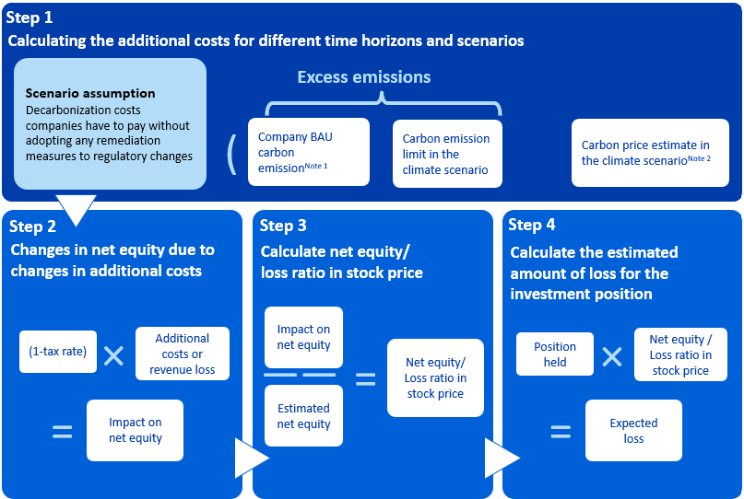

Note:

1. The Business-As-Usual (BAU) Scenario is referenced from the International Energy Agency (IEA) to predict the carbon emission growth rates for selected industries.
2. The predicted carbon prices for each year under various scenarios are referenced from the Central Banks and Supervisors Network for Greening the Financial System (NGFS).

* Scenario Analysis Results

Based on the analysis results of high-climate-risk industries mentioned above, we incorporated the equity investment assets in the six high-climate-risk industries into the stock price valuation model. The expected loss amounts due to carbon fees under two scenarios (1.5°C / <2°C) were calculated, and the impact ratios (i.e., the expected loss amount for the industry in that year divided by the industry’s asset scale) are presented in the following chart. It shows significant changes in the impact levels on equity investment positions in the cement industry, aviation industry, and steel industry over the years. The impact level under the 1.5°C scenario changes more significantly than under the <2°C scenario. The cement industry, due to its relatively high carbon emission intensity compared to other industries, faces a larger impact in both the 1.5°C and <2°C scenarios. However, its future carbon emission growth rate is expected to decrease with improved production efficiency and technological advancements. The aviation industry and steel industry are expected to have slightly higher future carbon emission growth rates than other industries, leading to a higher impact level on these industries.

<2ﾟC

<1.5ﾟC

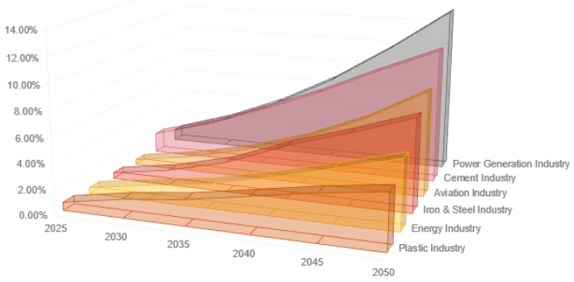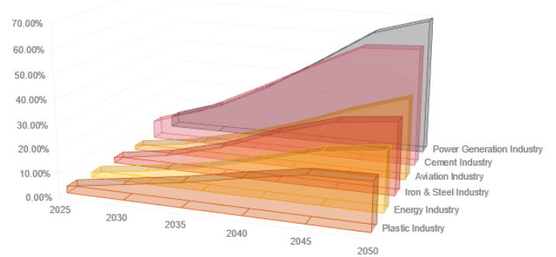Note: The industry impact level is the ratio of the expected loss amount of the investment position under the climate scenario to the exposure amount as of the benchmark date (end of December 2023).

* Response Strategies Based on Scenario Analysis Results

The Company’s climate change response management measures developed based on the assessment results are as follows:

1. To ensure the appropriateness of climate change risk management in investment, the Company has set climate change risk monitoring indicators. The Risk Management Department regularly monitors the usage of these indicators and reports significant climate change risk management information to the Audit Committee and the Board of Directors.
2. When climate change risks reach the climate change risk monitoring indicators, the Risk Management Department will assess the exposure level of the climate change risks, specify the reasons and handling plans, and submit them to the Chairman for approval.

**Bottom-up Physical Risk Scenario Analysis: Quantitative Assessment of Flood Impact on Operating Sites Across Taiwan**

The increasing severity of extreme weather events such as heavy rain and flooding has become a global concern. Should such events occur, they could impact the Company’s operating sites and significantly affect business activities. To address that, in cooperation with Yuanta Group and referencing the flood potential maps for various townships in Taiwan under RCP 2.6 (<2°C) and RCP 8.5 (4°C) scenarios published by the National Science and Technology Center for Disaster Reduction on the Climate Change Disaster Risk Adaptation Platform, the physical risk flood potential scenario analysis was conducted. This analysis focuses on operating sites located in areas under high flood risk to evaluate the potential impact on the Company’s asset value under future climate scenarios.

* Assessment Method

Disaster Risk Model

* Adopted Climate Scenarios

Flood potential maps for various townships in Taiwan under RCP 2.6 (<2°C) and RCP 8.5 (4°C) scenarios published by the National Science and Technology Center for Disaster Reduction on the Climate Change Disaster Risk Adaptation Platform.

1. Selection of analysis targets: Geographic locations of operating sites

2. Overlay analysis: Identify operating sites located in areas under high flood risk

3. Impact ratio analysis: (Number of affected operating sites / Total number of operating sites) X 100%

* Scenario Analysis Results

1. Under the RCP 2.6 scenario, none of the operating sites and company-owned assets in Taiwan are located in high flood-risk areas by the end of this century.
2. Under the RCP 8.5 scenario, approximately 33.33% of operating sites and company-owned assets in Taiwan are located in high flood-risk areas by the end of this century.

* Response Strategies Based on Scenario Analysis Results  
  In cooperation with Yuanta Group, the Company has established robust physical risk adaptation measures for operating sites, as well as policies and procedures for major disaster event responses, such as “Operating Guidelines for Reporting Significant Incidents”, “Information Business Manual - Business Continuity and Disaster Recovery Management,” and “Crisis Management Policy and Procedures Rules”. These measures ensure that disasters that occur within the short term can be effectively managed.

To prevent operational interruptions or asset value impairment due to heavy rainfall or flooding, the expansion or relocation of operating sites considers factors such as climate change risks, flood control measures, and disaster insurance in accordance with the “Yuanta Financial Holdings Operating Site Selection Evaluation Form”. This ensures that future operational sites can withstand extreme climate impacts, thereby preventing and mitigating potential operational losses.

**Indicators and Goals**

**Indicators and Goals for Low-Carbon Operation Management**

Yuanta Securities actively aligns with Yuanta Group’s overall carbon reduction policy, utilizing systematic management to establish low-carbon operation management indicators and short, medium, and long-term goals. Moreover, these goals are actively implemented and tracked to consistently reduce the Company’s impact on climate change.

Greenhouse gas unit: tCO2e

|  |  |  |  |  |  |  |
| --- | --- | --- | --- | --- | --- | --- |
| **Greenhouse gas emissions** | **2021** | **2022** | **2023** | **2023**  **Goal** | **Achievement status** | **2024**  **Goal** |
| Category 1 | 681.48 | 652.95 | 624.13 | Category 1 + Category 2 emissions 9,673.43 | Achieved | Category 1 + Category 2 emissions  9,467.61 |
| Category 2 | 8,795.76 | 7,747.2 | 7,105.5 |
| Category 1+ Category 2 | 9,477.24 | 8,400.15 | 7,729.63 |
| Carbon intensity  (tCO2e/ NT$1 billion revenue) | 0.1260 | 0.1686 | 0.1256 |
| Data coverageNote6 | 100% | 100% | 100% |
| Categories 3 to 6 Note7 | 1,732.96 | 1,451.47 | 1,560.99 |

Note:

1. Based on ISO 14064-1 standards, Categories One to Four are audited using the operational control approach to define the audit boundary, with 2020 as the baseline year when a full site audit was conducted.
2. Emissions are calculated using the emission factor method: Emissions = Activity Data × Emission Factor × Global Warming Potential (GWP).
3. Greenhouse gas emissions in Categories One and Two include carbon dioxide, methane, nitrous oxide, and hydrofluorocarbons.
4. Category One emissions mainly come from gasoline and refrigerants, and their emission factors are calculated based on the “Ministry of Environment Greenhouse Gas Emission Factors Management Table 6.0.4” announced by Executive Yuan.
5. Category Two emissions are from purchased electricity, quantified using the calculation method provided in the “Ministry of Environment Greenhouse Gas Emission Inventory Guidelines” announced by Executive Yuan, with emission factors calculated based on the latest historical electricity carbon emission factors announced by the Energy Bureau of the Ministry of Economic Affairs in 2023.
6. Data coverage refers to the proportion of sites included in Category One and Category Two statistics out of the total number of sites for the year.
7. Categories Three to Six include items such as business travel, waste disposal, and purchased electricity (upstream emissions).

**Science-Based Carbon Reduction Targets**

Yuanta Securities’ parent company, Yuanta Financial Holdings, became a signatory of the “Science Based Targets Initiative (SBTi)” in 2019. The targets for Categories One and Two were set in 2020, and the target for Category Five (investment and financing) was set in 2022. In the same year, these SBT targets passed the SBT verification.

|  |  |  |  |  |
| --- | --- | --- | --- | --- |
| **SBT category** | **Yuanta Group's SBT Targets** | **2023 Goal** | **Achievement status** | **Methodology** |
| Category 1 and Category 2 | 42% reduction in absolute GHG emissions by 2030 compared to 2020. | 12.6% reduction in absolute GHG emissions compared to 2020. | 22.05% reduction in absolute GHG emissions compared to 2020. | Absolute Contraction Approach |
| Category 5 -Investment and Financing | The “Publicly Listed Company Equity and Debt Investment” item in the investment and financing category pertains to Yuanta Securities’ operation. By 2027, 39% of the equity and debt investment portfolio in publicly listed companies held by the proprietary trading department (calculated based on investment amount) will have set SBT targets. | Relevant parts setting SBT target ratio reaches 20% | Relevant parts setting SBT target ratio reaches 31% | Engagement Approach |

Note: The publicly listed equity and debt investment portfolio includes common stocks, preferred stocks, corporate bonds, exchange-traded funds (ETFs), real estate investment trusts (REITs), and mutual funds.

**Assisting Clients in Setting Carbon Reduction Targets**

The Company’s investment banking services primarily assist clients with their IPOs by planning the schedule based on the issuing company’s operational status and disclosing and evaluating various information in accordance with regulatory requirements. During the guidance process, we remind and advise clients to set carbon reduction targets and assist them in disclosing information related to their carbon reduction plans or policies. For the underwriting positions of publicly listed companies, the investment banking business department checks whether clients meet responsible investment criteria during case meetings and underwriting meetings in accordance with the Company’s “Principles for Responsible Investment Decision Making” and “Underwriting Committee Operation Rules”. This is considered in investment decision-making and investment target selection.

**Internal Carbon Pricing (ICP) Mechanism**

Referencing foreign carbon fee prices and the estimated carbon costs under the 2050 net-zero carbon scenario, Yuanta Group trialed a carbon pricing mechanism in 2023, setting the internal carbon price at NT$1,500 per ton of carbon for corporate greenhouse gas emissions costs. In adherence to the concept of“reducing carbon emissions scientifically and assigning values to carbon rights,” the Company’s carbon reduction targets are set based on 2020 as the baseline year with the ISO 14064 greenhouse gas audit results as references. The carbon reduction pathway was set using the SBT methodology and was verified by SBTi in 2022. After passing the verification, the Company integrated the sustainability and carbon reduction-focused mindset into the daily operations of every employee through smart energy monitoring, replacing old high-energy-consuming equipment, and introducing the transition to green electricity. During the trial period from January to November 2023, the carbon reduction target achieved a reduction of 517.3 tCO2e compared to the same period in 2022. The actual reduction was 816 tCO2e, exceeding the 8% reduction target, which is equivalent to a carbon price of approximately NT$1.224 million.

**Nature-related Financial Disclosures**

The company jointly participated in the nature-related financial disclosure project of parent company Yuanta Financial Holdings, and parent company Yuanta Financial Holdings' "Climate and Nature-related Financial Disclosure Report 2023" has included the taskforce on nature-related financial disclosure (TNFD) chapter, which takes the business operations activities of Yuanta Financial Holdings and its subsidiaries (including Yuanta Securities) in 2023 as the disclosure boundary, covering four core projects related to climate and nature: governance, strategy, risk management, and indicators and goals. Assess the impact and dependence of the group's operations on the natural environment, as well as the derived risks and financial impacts, to promote the common development of ecology and economy; at the same time, introduce IFRS S2 standards to further focus on climate issues, and evaluate the group's resilience analysis and quantification in the face of climate change financial impact and describe the Group’s climate transformation strategy and performance. For relevant content, please see pages 66 to 78 of Yuanta Financial Holdings’ “Climate and Nature-Related Financial Disclosure Report 2023,” which includes subsidiary-related risk levels, nature-related policies and concerns, natural risk management responses, etc., please see Page 78 of the report.

## 7.2 Green Operations

Yuanta Securities upholds its commitment to environmental protection by adhering to environmental regulations and international standards. The Company aims to appropriately protect the sustainability of the natural environment in its operation. In addition to the implementation of various policies in daily business operations to reduce energy and resource consumption and minimize the environmental impact of its activities, we also actively participate in various environmental sustainability initiatives. Through its involvement, the Company encourages society to place greater importance on environmentally sustainable development.

**Lower-Carbon Operation**s

**Energy Consumption**

| **Energy type** | **Unit** | **2022** | **2023** | **2023 Target** | **Achievement status** | **2024 Target** |
| --- | --- | --- | --- | --- | --- | --- |
| Non-renewable energy | | | | | | |
| Non-renewable energy (purchased)Note1 | kWh | 14,724,487 | 14,354,549 | Reduce purchased non-renewable energy to 17,775,851 kWh | Achieved | Reduce purchased non-renewable energy to 17,397,641 kWh |
| Other energyNote1 | GJ | 1,945.31 | 2,037.09 |
| MWh | 540.36 | 565.86 |
| Total energy consumption | GJ | 54,963 | 53,722.77 |
| MWh | 15,267.51 | 14,923 |
| Energy intensity | GJ/ NT$ million | 1.1033 | 0.8736 |
| Renewable energy | | | | | | |
| Power Consumption of Green Power Wheeling | kWh | 332,267 | 844,135 | Green electricity capacity reaches 1,000,000 kWh | 84.41% | Green electricity capacity reaches 1,000,000 kWh |
| Total renewable energy consumption | GJ | 1,196.38 | 3,039.43 |
| Data coverage rate Note3 | | 100% | 100% |
| Annual carbon reduction | tCO2e | 169.12 | 417.85 |

Note:

1. Our primary usage of energy is externally purchased electricity, with other energy sources including gasoline and diesel.
2. The energy calorific value conversion is referenced from the units published by the International Bureau of Weights and Measures and the values announced in the “2021 Energy Statistics Handbook - Energy Product Unit Calorific Value Table” by the Energy Bureau of the Ministry of Economic Affairs, calculated as 860 kcal/kWh for electricity, 7,800 kcal/L for gasoline, and 8,400 kcal/L for diesel. Conversion units used are 4.1868 kJ/kcal and 0.277778 MWh/GJ.
3. Data coverage refers to the proportion of sites included in the statistics out of the total number of sites for the year.
4. Calculations are conducted based on the latest electricity carbon emission factors announced annually by the Energy Bureau of the Ministry of Economic Affairs.
5. The annual target was not met due to the extended timeline of Taiwan Power Company’s renewable energy transition operations.

**Adoption of Environmental Management Systems**

The Company has adopted international management systems as follows. Through systematic management structures and procedures, various energy-saving plans are implemented, effectively improving energy efficiency while reducing energy expenditure and environmental impact.

|  |  |
| --- | --- |
| ISO 14001 Environmental Management System  ISO 50001 Energy Management System  ISO 14046 Water Footprint Inventory | ISO 14064-1 Greenhouse Gas Inventory  ISO 45001 Occupational Health and Safety |

**Green Power Initiative Coverage**

In 2020, the Company signed the “Power Purchase Agreement” for renewable energy, marking the beginning of Taiwan’s financial green power era. Starting from the third quarter of 2021, we began transitioning to electricity from renewable energy sources. While we previously promoted renewable energy by purchasing renewable energy certificates (T-REC), we now directly join the green power initiative by using renewable energy. Two of our operating sites adopted 100% renewable energy, making us the first securities company in Taiwan with branches that use 100% green power. In 2022, we launched the second phase of our renewable energy project. In addition to the Ximen and Taichung branches, we planned for 41 more operating sites to use a total of 1.4 million kWh of renewable energy annually. From February 2023, the transition to green power has been initiated across our operating sites. By December 31, 2023, a total of 43 operating sites were using renewable energy, with a green power usage of 844,135 kWh.

**Energy Conservation Initiatives and Results**

|  |  |  |  |  |
| --- | --- | --- | --- | --- |
| **Energy conservation initiatives** | **Electricity consumption reduced (kWh)** | **Energy consumption reduced (MJ)** | **Carbon reduction performance**  **(tCO2e)** | **Costs**  **(1,000 NTD)** |
| Installing energy-saving LED lighting | 99,655 | 358,822 | 49.33 | 1,882 |
| Replacing old air conditioning equipment | 79,280 | 285,459 | 39.24 | 4,540 |
| Sum | 178,935 | 644,281 | 88.57 | 6,422 |

Note:

1. Installing energy-saving LED lighting: 1847 lights, mostly originally T5 grid lamps (61W), with a few cold cathode lamps (44W) and recessed lamps, were replaced with new LED lamps (26W). The calculation basis is an average daily usage of 7 hours, 250 days a year.
2. Operating sites where old air conditioning equipment was replaced include Baoqing Building, Wanhua Branch, and Fucheng Branch.
3. Calculations are conducted based on the latest 2022 electricity carbon emission factor of 0.495 (kg CO2e/kWh) announced by the Energy Bureau of the Ministry of Economic Affairs.

**Carbon Reduction Project**

**Paperless Carbon Reduction Action**

The Company incorporates sustainability concepts into its business management principles and promotes various paper reduction measures to reduce operational carbon emissions. As operational efficiency is enhanced through streamlining operating procedures, we also promote online meetings and online education and training. Other than reducing paper used in meetings and digitalizing operating systems, the Company also encourages employees to take public transportation, thereby reducing carbon emissions from commuting for meetings. The paperless initiatives have contributed to the reduction of approximately 46 million sheets of paper in 2023, equivalent to nearly 300 thousand tCO2e of greenhouse gas emissions. This shows that the Company is taking action to create a low-carbon workplace environment while implementing green financial services.

1. Paperless Operations: Electronic internal documents, online signing system, electronic payroll for employees.

2. Paperless meetings: Meeting materials are provided in electronic form, tablets are used at meetings for the Board of Directors and Audit Committee, and email communications are prioritized for routine affairs and announcements, reducing the paper usage while increasing administrative efficiency.

3. Paperless training: Establishment of online teaching system, E-Learning platform, the development of shared could platforms, databases and digitalized materials; slideshows or iPads for physical training courses.

4. Paperless business services: Adoption of digital services in marketing, account-opening, application operations, transactions, payment, and accounting (electronic statements/online account opening/online application/online orders, etc.)

5. Paperless daily life: Reduction in the use of paper cups and meal boxes

|  |  |  |
| --- | --- | --- |
| **Paperless Carbon Reduction Initiatives** | **Sheets of paper saved** | **Carbon equivalent reduced (kgCO2e)** |
| Warehouse inventory | 20,900,112 | 133,760.72 |
| Electronic statements advocacy | 15,245,544 | 97,571.48 |
| Digital contracts for OTC account opening | 8,627,458 | 55,215.73 |
| Digitalization of anti-money laundering statements | 532,749 | 3,409.59 |
| Digitalization of internal documents | 68,634 | 439.26 |
| Digitalization of employee salary slips | 173,000 | 1,107.2 |
| Yuanta E-Learning | 373,653 | 2,391.38 |
| Tablets for meetings | 169,893 | 1,087.32 |
| Sum | 46,091,043 | 291,573.09 |

Note:

1. The calculation of carbon emissions for paper usage data from the Ministry of Environment ’s Carbon Footprint Information Platform, where a pack of 500 sheets of A4 photocopy paper generates 3.20 kgCO2e.
2. Paperless measures fall under Category Four of greenhouse gas emission reductions.
3. Explanation of the calculation basis for data outside the system reports:
   * 1. Digitalization of internal documents: 9,278 received documents (estimated at 3 sheets per document), 13,600 sent documents (estimated at 3 sheets per document)
     2. Digitalization of employee salary slips: Saved approximately 173,000 sheets of paper. Calculation basis: Based on the estimated 5,000 employees, with an average of 2 sheets of paper per salary slip monthly, totaling 120,000 sheets per year; other types of pay slips (including festival bonuses and awards) average 10.6 sheets per person annually, totaling 53,000 sheets per year.
     3. Yuanta E-Learning: Saved approximately 373,653 sheets of paper. Calculation basis: Each hour of class involves an average of 10 pages of handouts. If printed 2-in-1 double-sided, it results in 2.5 sheets of paper per person per class; in 2023, the total hours of online courses on the platform were 149,461 hours * 2.5 sheets of handouts.
     4. Carbon reduction results for the measure tablets for meetings are calculated based on the Remuneration Committee, Audit Committee, and Board of Directors meetings. Calculation basis for the Remuneration Committee: 9 attendees per meeting, estimated 50 sheets of paper per meeting, 6 meetings per year, saving approximately 2,700 sheets of paper. Calculation basis for the Audit Committee and Board of Directors: number of meetings held annually and the average number of attendees, including the agenda (with attachments) and minutes (with excerpts) of the March meetings in terms of the number of sheets.

**Water Resources Management**

Yuanta Securities has implemented the ISO 14046 Water Footprint Inventory verification. All water resources are sourced from tap water and are used solely for normal business operations. Wastewater is discharged into the sewer system in compliance with regulatory requirements, ensuring no illegal activities that harm the environment. The inventory scope includes all operating sites of the Company, with a coverage rate of 100%. Based on the water footprint inventory, water usage at each site is tracked and investigated for any abnormalities in water equipment and pipelines to understand the impact of our business activities on water resources. Moreover, data management and target setting are implemented to evaluate water resource usage. To strengthen water resource management, the Company has installed a rainwater harvesting system in company-owned buildings (Financial Holdings Building), replaced faucets with water-saving ones at operating sites, and periodically promoted water-saving measures to its employees.

**Water Withdrawal Data**

|  |  |  |  |  |  |
| --- | --- | --- | --- | --- | --- |
| **Item** | **2022** | **2023** | **2023 Target** | **Achievement status** | **2024 Target** |
| Water Withdrawal from tab water  (1 million liters) | 75.20 | 75.19 | 91.89 | Achieved | 91.89 |
| Water use intensity (liter/m2) | 738.82 | 713.03 | 1042.82 | Achieved | 1042.82 |
| Data coverage Rate | 100% | 100% | - | - | - |

Note: The data of water consumption inventory cover all business locations.

**Waste Management**

The waste produced by the Company is primarily general domestic waste, generated from various internal and external business operations. No hazardous waste is produced, nor is there any waste in special disposal categories. We have long-term contracts with external service providers for waste management. General waste is transported to incineration plants, while recyclable waste and food waste are handled by recycling vendors, effectively managing waste to maintain a clean corporate environment. Internally, the Company implements waste reduction policies and promotes proper waste sorting among employees to ensure effective recycling. Waste disposal vendors are carefully selected, and thorough engagement with contracted service providers is implemented to ensure that their disposal methods do not involve any illegal activities that could harm the environment, thereby ensuring that the Company’s waste is handled prudently and legally.

**Waste Data**

|  |  |  |  |  |  |  |  |
| --- | --- | --- | --- | --- | --- | --- | --- |
| **Waste category** | **Treatment** | | **2022** | **2023** | **2023**  **Target** | **Achievement status** | **2024**  **Target** |
| General waste (ton) | Waste incineration | No energy recycling | - | - | Waster per capita  67.78  (kg/per person) | Achieved | Waste per capita  67.78  (kg/per person) |
| Energy recycling | 176.01 | 166.9 |
| Recyclable waste | | 86.03 | 88.97 |
| Total volume | | 262.04 | 255.87 |
| Waste per capita (kg/per person) | | 50.96 | 49.10 |
| Data coverage Rate | | 100% | 100% |

Note:

1. The waste audit scope for 2023 includes all business locations (including subsidiaries Yuanta Securities Finance and Yuanta Insurance Brokers), with a 100% coverage.
2. The number of employees within the audit scope for 2023 is 5,211.
3. Since 2019, the Company has been using actual weight measurements for waste data statistics.

**Waste Reduction Action**

Yuanta Securities echoes Yuanta Group’s policies and is committed to reducing waste at the source. In a consistent effort to promote specific measures, we encourage employees to bring their own meals and use eco-friendly utensils. Moreover, water dispensers, rice steamers, and microwaves are available in the pantry to facilitate the implementation of waste reduction measures. In line with government environmental protection policies, we do not use disposable or melamine tableware, nor do we offer cups of water or plastic bottled water, striving to establish a sustainable, healthy, and eco-friendly workplace. Additionally, waste sorting and recycling are enforced, and the waste is weighed to track the progress of waste reduction targets on each floor.

**Active Participation in Environmental Sustainability Initiatives**

Yuanta Securities adheres to the United Nations Sustainable Development Goals (SDGs), focusing on natural ecological protection and biodiversity issues. We echo the "Do Tamsui River a Favor" initiative launched jointly by the Common Wealth Magazine and corporate citizens attentive to water resources. Since signing the “Tamsui River Convention” in 2020, we have been promoting various energy-saving and carbon-reduction plans, including proper management of energy resources, water resources and waste, reducing paper usage, digitalizing data and promoting paperless practices, increasing green procurement, and raising the proportion of purchasing green power and renewable energy.

To raise awareness among more enterprises about climate change and net-zero carbon emissions, the Company has invited corporate clients to sign this convention as well. In June 2023, we invited numerous corporate clients, including NewSoft Technology, Business Today, HuaShin Paper Stationery, Multisuns Communication, Dawning Technology, Ultramate, Fang Hung Engineering, UNITEC, Get Technology, VITALIC Consulting, Jing Yuan Bao, Taiwan Secom, and Jebo Advertising Engineering, to participate, contributing collectively to Taiwan’s ecological environment.

Other Environmental Sustainability Activities

The Company also participates in or initiates other activities promoting environmental sustainability, such as turning off lights for one hour on Earth Day, beach cleanups, campus tree-planting, and the Family Day event “Yuanta Loves the Earth” carbon-reduction walk. For more details, please refer to Chapter 6, Section 2, “Public Welfare Investment and Results”.

## 7.3 Sustainable Supplier Management

In adherence to Yuanta Group’s sustainable development strategy, Yuanta Securities actively supports and encourages our suppliers to jointly implement corporate social responsibility, promote environmental sustainability, and uphold fundamental human rights. The Company has also set internal KPIs and sustainability indicators to consistently track implementation status.

|  |  |  |  |
| --- | --- | --- | --- |
| **Sustainable supply chain management indicator** | **Implementation status in 2023** | **2024 Goal** | **2025 Goal** |
| Audit suppliers in ethics and sustainability based on the ISO 20400 Sustainable Procurement Guidance | 100% compliance with the ISO 20400 Sustainable Procurement Guidance in supplier management | Continue to optimize supplier management procedures in accordance with the ISO 20400 Sustainable Procurement Guidance | |
| Request supplier compliance with the “Supplier’s Terms and Conditions for Sustainable Procurement” | 100% implementation of incorporating the “Supplier’s Terms and Conditions for Sustainable Procurement” and “Integrity Management Terms” in supplier contracts | Implement 100% coverage of supplier signing | |
| Regularly audit major suppliers | Issued 42 self-assessment questionnaires in 2023, with a 100% response rate. | 1. 100% response rate for self-assessment questionnaires 2. 30% on-site inspection rate for high-risk suppliers | 1. 100% response rate for self-assessment questionnaires 2. 50% on-site inspection rate for high-risk suppliers |
| Supplier sustainable management and evaluation | Completed engagement and guidance operations for 2 Grade C suppliers, tracked and improved results in 2023. | 1. Achieve a reduced percentage of Grade C suppliers than the previous year 2. Remove Grade C suppliers from the priority procurement list and gradually refrain from collaboration | 1. Achieve a reduced percentage of Grade C suppliers than the previous year 2. Remove suppliers labeled as Grade C for three consecutive years from the procurement list |

Note: Grades A, B, and C are determined by the annual supplier evaluation. Grade A is for excellent suppliers, grade B is for qualified suppliers, and grade C is for suppliers that require engagement and guidance.

**Supplier Management Measures**

The Company includes sustainable procurement terms and integrity management terms in contracts to implement supplier risk control. Additionally, supplier self-assessments and evaluations are conducted to analyze suppliers’ sustainability risks and track and improve the results. Through quarterly supplier conferences and training sessions, we invite suppliers to join sustainable initiatives. ESG aspects are also considered when selecting new suppliers.

|  |  |  |
| --- | --- | --- |
| **ESG Aspects Considered in New Supplier Selection** | | |
| Environmental Protection | Society | Corporate Governance |
| Engage with suppliers on the implementation of concrete climate change management measures | Advocate supplier compliance with the “Supplier Sustainable Procurement Guidance” | Understand suppliers’ integrity management status |
| Request suppliers to provide products with environmental protection, energy-saving, water-saving and green building labels; minimize environmental harm during the manufacturing or service provision processes and comply with relevant environmental regulations and pollution prevention measures. | Suppliers involved in violations of occupational safety and health regulations are required to submit the “Supplier Safety and Health Commitment”. Contracts for construction and maintenance projects should include the “Occupational Safety and Health Provisions to Prevent Occupational Hazards”. | Check the Judicial Yuan website for any records of suppliers violating ethical behavior; include integrity management terms in contracts. |

**Sustainable Procurement Guidelines**

In accordance with Yuanta Financial Holdings’ sustainable procurement policy, Yuanta Securities has implemented the ISO 20400 Sustainable Procurement Guidance in 2020 and obtained certification for its comprehensive sustainable procurement process. Supplier’s Terms and Conditions for Sustainable Procurement and integrity management terms are included in contracts. We inspect the integrity management and occupational safety and health of trading partners as needed and request suppliers to commit to and comply with relevant sustainable development regulations, covering the environmental, social, and governance aspects to ensure supplier risk control.

**Supplier Sustainability Risk Assessment**

The Company requests its suppliers to fill out the annual self-assessment questionnaires, which are reviewed along with publicly available illegal records of the suppliers. This allows the Company to effectively take notice of deficiencies in specific indicators and ensure risk control. The self-assessment targets are suppliers whose annual transactions exceed a certain amount. The assessment covers six categories: human rights, labor practices, consumer issues, integrity management, environment, and health and safety. The self-assessment questionnaire analyzes the current risk levels of suppliers, including their sustainability awareness and any major deficiencies or illegal activities. The results are categorized into three levels for sustainability risks, high, medium, and low. For suppliers with high sustainability risk, the Company conducts random document and on-site audits to track their sustainability risk improvement. In 2023, 42 self-assessment questionnaires were collected, with a 100% response rate, including 2 high-risk, 5 medium-risk, and 35 low-risk results.

The annual supplier evaluation results are also divided into three levels: A (excellent), B (qualified), and C (engagement required). Grade A suppliers are publicly commended at the supplier conference, while Grade C suppliers receive engagement and guidance to help improve their performance.

**Sustainable Supply Chain Engagement**

For medium and high-risk suppliers, we conduct observations and provide improvement suggestions on sustainable actions, explaining the implications of high-risk issues, relevant international trends, and regulatory standards. The subsequent tracking and confirmation actions for high-risk suppliers are as follows:

1. Explain to all high-risk suppliers individually, provide analysis results and feedback on the self-assessment questionnaire, understand the reasons for high risk in detail, and track the improvement measures and results of their risk and illegal actions, ensuring 100% tracking and confirmation of their risk mitigation and remedial measures.
2. Require suppliers who have violated regulations to provide written reports on improvement measures, and track and confirm that the supplier has implemented improvement actions.
3. Conduct on-site audits for high-risk suppliers and provide analysis reports and improvement suggestions based on their specific risks to reduce the Company’s risk exposure in procurement.

**Green Procurement**

Yuanta Securities has established standards for green procurement in the “Procurement and Disposal Operation Guidelines” and “Supplier Management Guidelines” to promote the development of a green production chain, reduce environmental impact, and fulfill corporate social responsibility in collaboration with suppliers. Products with environmental protection, energy-saving, water-saving, and green building labels are given priority in procurement projects. Through green procurement and sustainable supplier management, we actively exert green influence and support local green enterprises with practical actions, promoting the market’s thriving development of low-carbon sustainable goods and services while simultaneously reducing procurement risks.

Furthermore, in support of Taiwan’s local economic development and in an effort to stabilize community relationships for shared prosperity and environmental friendliness, the Company prioritizes local suppliers for procurement. This year, we procured from 433 local suppliers, accounting for 97.7%, with 2,327 local procurement cases, accounting for 99.5%.

**Green Procurement Performance**

Echoing various green procurement initiatives, the Company has been an active participant in the “Green Procurement Program for Private Enterprises and Organizations” promoted by the Taipei City Government. Yuanta Group has been recognized as an “outstanding performance in green procurement” organization by the Taipei City Government for 13 consecutive years (2011-2023) and has been commended by the Environmental Protection Administration for outstanding green procurement performance for 12 consecutive years (2012-2023). In 2023, our green procurement amount was NT$53,373,000, accounting for 5.24% of the total procurement amount.

|  |  |  |
| --- | --- | --- |
|  | 2022 | 2023 |
| Green procurement amount (1,000 NTD) | 111,362 | 53,373 |
| Total procurement amount (1,000 NTD) | 1,011,330 | 1,018,074 |
| Percentage of green procurement out of total procurement | 11% | 5% |

The Company also echoes the Environmental Protection Administration’s continuous promotion of the “Use Instead of Own” concept by gradually establishing a circular economy business model that replaces purchasing with leasing, thereby reducing resource demand. We also echo the Environmental Protection Administration’s “Environmental Points Collection” project, inviting employees and their families to take part. This project promotes green consumption using a points platform, aiming to incentivize people to join in on environmental protection efforts with points and validate the value of environmental actions. The Company has purchased 30 million environmental points from the Environmental Protection Administration to reward staff who voluntarily participated in environmental sustainability-related activities.