## 3.1 Corporate Governance

**Board Structure and Operation**

**Board Structure**

The directors of Yuanta Securities are selected following the Company’s “Corporate Governance Best Practice Principles” and directly appointed by the parent company, Yuanta Financial Holdings, in accordance with the pertinent laws. The Board is composed of directors and does not have executive directors. According to the Company’s “Articles of Association”, the term of each Board is three years, and reappointment is permissible. The average term of directors is four years. The current (eleventh) Board of Directors’ term runs from June 1, 2022, to May 31, 2025, consisting of 11 directors and 7 independent directors, with independent directors making up 39% of the Board.

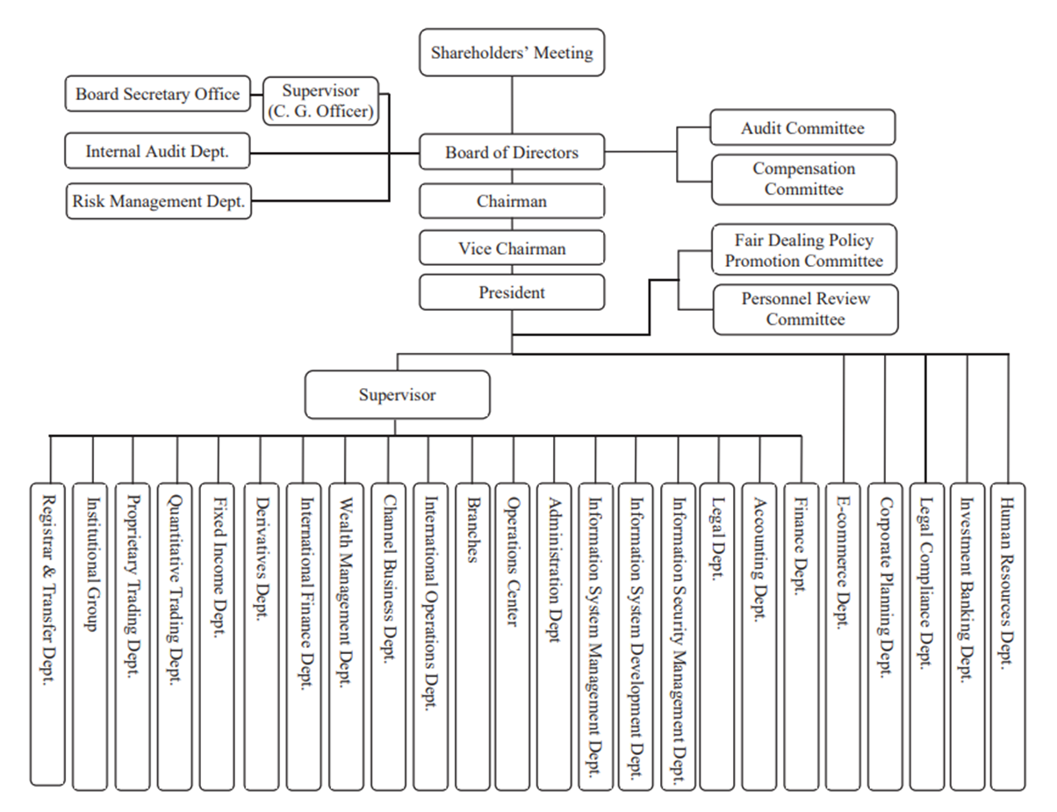**Yuanta Securities Organizational and Operational Management Chart**

**Board Attendance**

The Company’s “Board Meeting Rules” clearly stipulate the board meetings’ agenda, operational procedures, matters to be recorded in minutes, announcements, and other compliance requirements. It also requires that the Board meets at least once a month and that individual directors’ annual attendance rates (excluding proxies) should reach over 80%, which is included in the director performance evaluation. In 2023, the Board met 16 times, with individual director attendance rates reaching 99%.

**Functional Committees under the Board**

The division of responsibilities among the Board of Directors, the Chairman, and the President is handled in accordance with the Company’s “Division of Authority and Responsibility Regulations”, “Division of Authority and Responsibility Table”, and “Responsibility Hierarchy Table”. The functional committees under the Board are the Audit Committee and Remuneration Committee. The primary authority of the Audit Committee is stipulated in Article 6 of the Company’s “Audit Committee Charter”, while the Remuneration Committee is responsible for establishing and regularly reviewing the policies, standards, and structures for performance evaluation and remuneration of the Company’s directors and managers, as well as periodically assessing their compensation.

|  |  |  |  |  |
| --- | --- | --- | --- | --- |
| Committee | Members | Minimum number of meetings per year | Number of meetings held in 2023 | Average committee member attendance rate |
| Audit Committee | The committee is composed of all independent directors. | 12 | 17 | 100% |
| Remuneration Committee | The committee is composed of independent directors and the number of members should be no less than three. | 2 | 5 | 100% |

**Committees under the President**

The committees under the President include the Promotion Committee for Treating Customers Fairly Principles and the Personnel Review Committee. The former is responsible for promoting matters related to fair customer treatment, while the latter is established to enhance the fairness and objectivity of handling employee reward and punishment cases.

|  |  |  |  |
| --- | --- | --- | --- |
| Committee | Members | Number of meetings held in 2023 | Average committee member attendance rate |
| Promotion Committee for Treating Customers Fairly Principles | The committee is composed of supervisory of related units, the Legal Department, Corporate Planning Department, and Corporate Governance Officer, as well as the heads of the Legal Compliance Department, Risk Management Department, Internal Audit Department, and Legal Department. | 8  (4 regular meetings and 4 ad-hoc meetings) | 94% |
| Personnel Review Committee | The committee is composed of the heads of the Legal Department, Legal Compliance Department, and Human Resources Department as ex officio members. Other members are managers above the department level appointed by the President, who also appoints one member as the chairperson of the committee. | 0 | - |

**Professional, Diverse, and Independent Board of Directors**

Yuanta Securities’ Board of Directors consists of 18 members, including one female director. All members possess comprehensive professional backgrounds in finance, securities, financial accounting, information technology, information security, risk management, and mergers and acquisitions. They also have seasoned industry experience and knowledge in financial holding, banking, securities, insurance, information technology, and construction industries. This diversity and expertise contribute to improving the quality of board decisions and strengthening internal oversight and management.

**Age Distribution of the Board**

The age distribution of the Company’s directors spans multiple generations, contributing to a diverse exchange of experiences during deliberations. The average age of the directors is 65.

|  |  |  |  |  |  |
| --- | --- | --- | --- | --- | --- |
| Age | 41-50 | 51-60 | 61-70 | Over 71 | Sum |
| Number of people | 1 | 3 | 9 | 5 | 18 |
| Percentage | 5% | 17% | 50% | 28% | 100% |

The Company’s “Rules on the Scope of Directors’ Responsibilities” clearly outline the main responsibilities of directors. Independent directors, in addition to following the previously mentioned rules, must also adhere to the “Rules on the Scope of Responsibilities of Independent Directors”. Independent directors must maintain their independence in performing their duties, and the Company must not obstruct, refuse, or evade the execution of duties by independent directors.

To ensure independence, the Company’s “Corporate Governance Best Practice Principles” stipulate that, according to the Articles of Incorporation, there should be at least two independent directors, with independent directors not being less than one-third of the total number of directors. Independent directors shall possess professional knowledge and shall not serve more than three consecutive terms. Additionally, they should not concurrently serve as directors (including independent directors) or supervisors of more than five companies. The summary of independence requirements is detailed in the table below. Furthermore, independent directors and non-independent directors may not change their status during their term of office to ensure the objective exercise of their powers.